Print Management System
College of Computing and Mathematics

SRS Document
Date: TBA
Project Motivation 2
Project Users 2
Administrator (Admin) 2
Technician 3
Standard User 3
System Overview 4
System Context Diagram 4
Use Case Diagram 5
Use Case Description 6
UC-01: Authenticate User 6
UC-02: Request Print Job (Submit to Print Queue) 7
UC-03: View Own Printing History Log 9
UC-04: Add Printing Device 10
UC-05: Remove Printing Device 11
UC-06: Manage Printing Queues 12
UC-07: Modify User Quota 13
UC-08: Manage User Access 14
UC-09: View Logs, Cost Calculations, and Analytics Dashboard 14
UC-10: Receive and View System Error Notification 15
UC-11: Modify Technician Privileges 17
Functional Requirements Specification 18
1. Authentication & Authorization 18
2. Print Job Management (Standard User) 18
3. Print History 19
4. Device & Queue Management (Administrator) 19
5. User & Quota Management (Administrator & Technician) 19
6. User & Quota Management (Administrator & Technician) 20
7. User & Quota Management (Administrator & Technician) 20
8. Role & Privilege Management 20
Non-Functional Requirements Specification 21

Project Motivation
The primary motivation for this project is to replace the existing PaperCut printing solution used within the College of Computing and Mathematics. Although PaperCut meets basic printing needs, its recurring licensing and usage costs have become a financial burden, and its proprietary nature limits flexibility, transparency, and long-term institutional control.
The proposed Printing Management System aims to provide a cost-effective, internally owned alternative that eliminates recurring fees while giving the college full ownership of system data, features, and future enhancements. A key driver of this project is the need for improved visibility into printing usage and expenses through analytics and cost calculation capabilities, enabling informed decision-making and more effective cost management.
The system will serve all faculty members, staff members, and undergraduate and graduate students across all departments in the college. It will support multiple user roles, including administrators, technical support staff, and normal users, ensuring secure access, efficient management, and ease of use while reducing costs without compromising printing services.

Project Users

Administrator (Admin)
The Administrator is the highest-privileged user role in the Printing Management System and has full access to all system functionalities. The Admin is responsible for adding and removing printing devices, deleting and configuring print queues, modifying user printing quotas, managing user access by suspending or restricting users in cases of misuse, accessing detailed user and device printing history logs, viewing and analyzing printing cost calculations, and accessing the analytics dashboard to review usage trends and system statistics, ensuring effective control, accountability, and informed decision-making.

Technician
The Technician role has limited administrative access within the Printing Management System and is responsible for supporting day-to-day system operation. Technical Support staff can manage (increase/decrease) user printing quotas, manage (suspend/unsuspend) user access, and receive system notifications related to errors and operational issues, such as printer faults, low ink or paper conditions, and system failures. This role does not have permission to add or remove printing devices, ensuring separation of responsibilities while enabling timely issue resolution and user support

Standard User
The Standard User represents faculty members and students who use the Printing Management System for regular printing activities. This role allows users to submit print jobs and view their own printing history logs, providing visibility into personal printing activity while ensuring that users can only access their own data. Standard Users do not have administrative or system management privileges.

System Overview

System Context Diagram

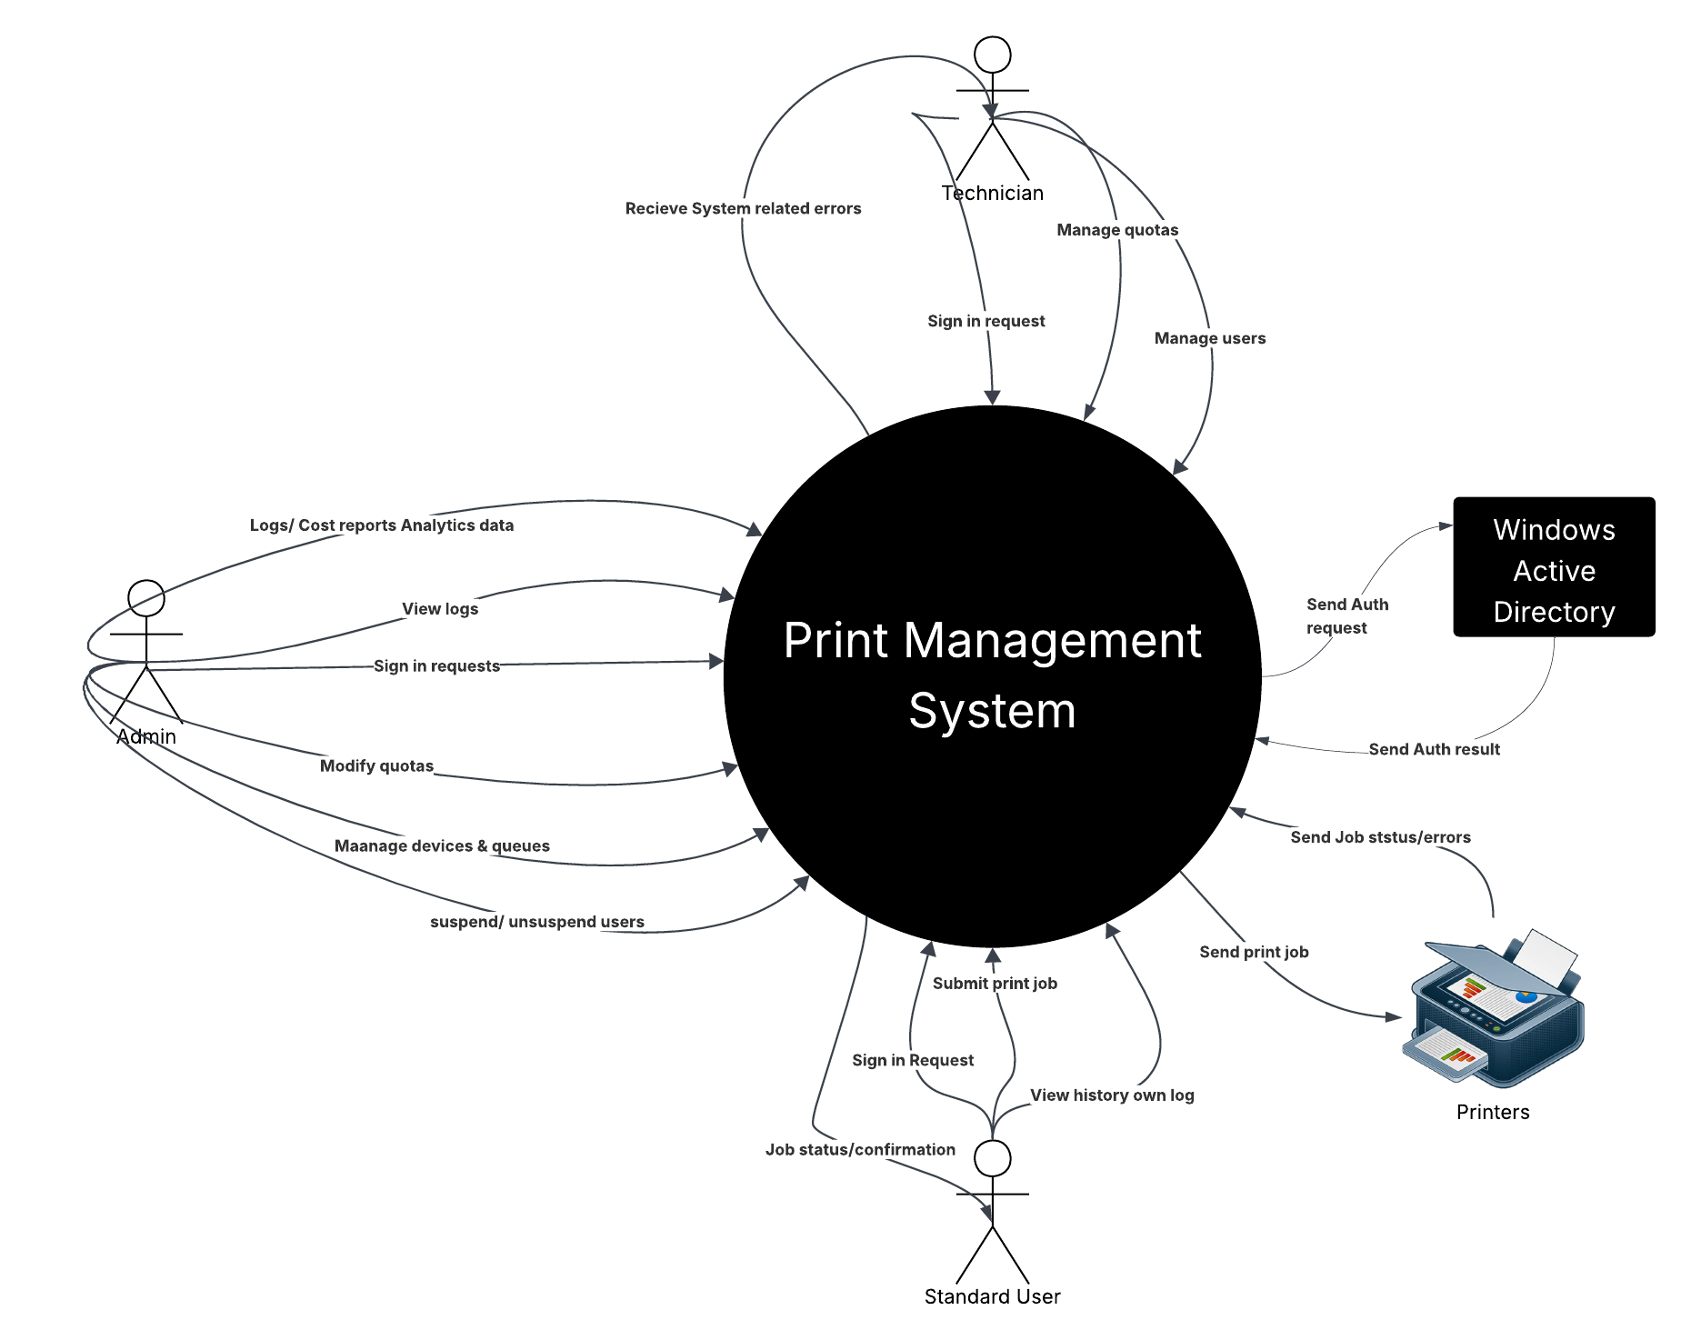

Use Case Diagram

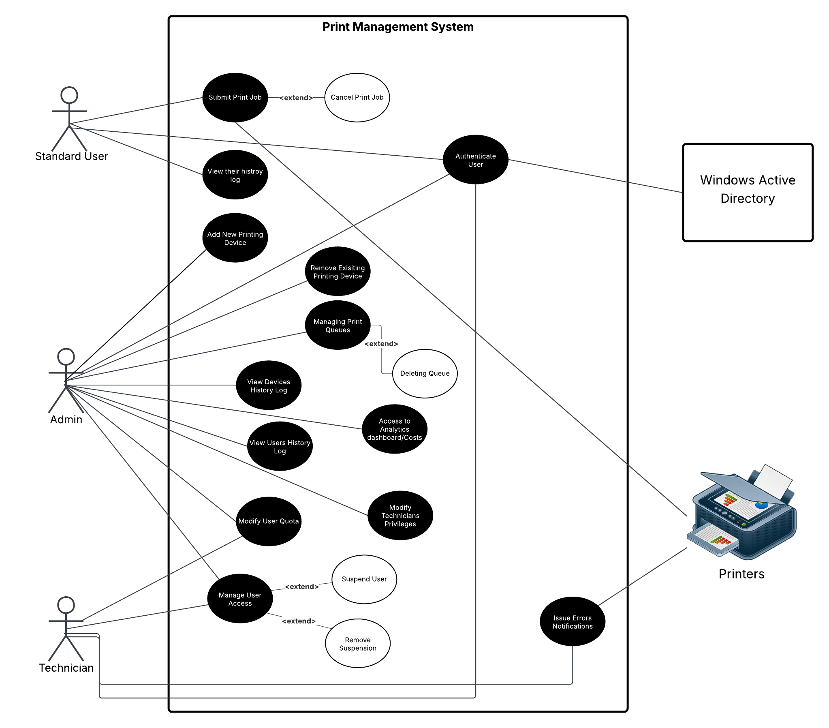

Use Case Description

UC-01: Authenticate User
Id | UC-01
Title | Authenticate User
Actors | Standard User (Primary) / Administrator (Primary)/ Technical Support (Primary)/ Microsoft Active Directory (Secondary)
Goal | Verify the identity of a user through Windows Active Directory in order to grant authorized access to the system.
Preconditions | - The user has a valid Active Directory account.  - The system is connected to the Active Directory service.
Postconditions | - The user is authenticated.  - The system retrieves user identity attributes (e.g., username, department, group membership).  - The system assigns appropriate role-based access permissions.
Basic Flow | - User attempts to access the Printing Management System.  - System prompts the user for credentials (or redirects to AD authentication service).  - User provides AD credentials.  - System sends authentication request to Active Directory.  - Active Directory validates credentials.  - Active Directory returns authentication result and user identity attributes.  - System grants access based on the user’s assigned role.
Alternate Flows | A1 — Invalid Credentials:  If the credentials are invalid, AD rejects the request and the system denies access, displaying an error message.  A2 — AD Service Unavailable:  If the system cannot communicate with AD, authentication fails and the system displays a service error message.  A3 — Suspended User:  If the user account is marked as suspended within the system, access is denied even if AD authentication succeeds.
Notes | All authentication attempts shall be logged for security and auditing purposes.  Role authorization shall be determined after successful authentication.  This use case is included in all secured system use cases

UC-02: Request Print Job (Submit to Print Queue)
Id | UC-02
Title | Submit Print Job (Submit to Print Queue)
Primary Actor | Standard User
Goal | Submit a document to the printing system and have it accepted for printing.
Preconditions | -User is authenticated via Windows Active Directory and has an active account.  -The user’s account is not suspended.  -At least one printing device/queue is available.  -The User’s quota is not exceeded
Postconditions | - A print job record is created in the system  - The job is placed in the selected print queue and is either printed or queued for printing  - User receives confirmation (or failure) and a job identifier.  - The file must be deleted from the printing queue.
Basic Flow | - User selects a document and chooses “Print” in the client or web interface.  - User selects target printer or queue and print options (copies, color/BW, pages).  - System validates user’s printing quota and print options.  - If quota is sufficient, system accepts the job, creates a job record, assigns a job ID, and forwards the job to the selected queue/device.  - The user go to the printer and second verify at the printer using their ID card or user credentials (user name + password).  - System returns confirmation to the user including job ID and estimated status.  - The job is printed when the printer is available; job status updates are recorded.
Alternate Flows | A1 — Insufficient quota: After step 4, if the user’s remaining quota is insufficient, the system rejects the job and informs the user (optionally offer to contact admin or request quota increase).  A2 — Invalid file / unsupported format: If the document format is unsupported or corrupted, the system rejects the job and provides an error message.  A3 — Printer fault / unavailable: If the target printer reports an error (paper out, low ink, offline), system notifies the user and suggests alternative queues (if available). The job may be held in a pending state.  A4 — Authentication failure: If ID authentication fails, the job is not accepted until authentication succeeds.  A5 — User cancels: User cancels before job submission; no job record is created.  A6 — Submitted file delayed: The system should delete the submitted file and it should not stay in the queue for more than 24 hours.
Notes | System shall record timestamp, user ID, job ID, pages, cost estimate, and target device in the job record.  System shall provide feedback to the user.  Jobs should be traceable for auditing (who submitted, when, cost, and device info).

UC-03: View Own Printing History Log
Id | UC-03
Title | View Own Printing History Log
Primary Actor | Standard User
Goal | The user should be able to view their own printing jobs history log on the system dashboard.
Preconditions | - User is authenticated via Windows Active Directory.  - User’s account is not suspended.
Postconditions | - The user is presented with a filtered list of their print jobs and associated details (date/time, pages, title)  -No system state is changed (read-only).
Basic Flow | - User selects “Printing History” from the application or web interface.  - System retrieves the user’s print-job records from the database, optionally applying default filters (most recent first, last 30 days).  - System displays the list with key details (job ID, date/time, pages, status) and provides controls for filtering, sorting, and exporting.  - User reviews entries; user may select an entry to view full details (including file name, options, and logs).
Alternate Flows | A1 — No history / empty result: System displays a “no records” message and guidance (e.g., “You have no print jobs in this period”).  A2 — Authentication failure: If Authentication session expired, user is prompted to re-authenticate.  A3 — Partial data retrieval error: If the system fails to retrieve historical records, an error is shown and the user is advised to retry or contact Tech Support.
Notes | System shall ensure users can only view their own records (data isolation).  Entries shall include job metadata required for auditing: job ID, timestamp, device, pages, cost, and final status.

UC-04: Add Printing Device
Id | UC-04
Title | Add Printing Device
Primary Actor | Admin
Goal | Add a new printing device to the system so it becomes available printing operations.
Preconditions | - Admin is authenticated via Windows Active Directory.
Postconditions | - A new printing device is added to the system configuration.  - The device appears in the device list and can be used for print queue setup.
Basic Flow | - Admin accesses the device management interface.  - Admin selects Add Printing Device.  - Admin enters the required device information (e.g., device name, IP address, location).  - System validates the provided information.  - System saves the device configuration and updates the device list.  - System confirms successful operation to the Admin
Alternate Flows | A1 — Invalid device configuration: System displays validation errors and requests correction.  A2 — Duplicate device detected: If a device with the same identifier (e.g., IP address/device name) already exists, the system rejects the request and notifies the Admin.
Notes | All device management actions shall be logged for auditing purposes.

UC-05: Remove Printing Device
Id | UC-05
Title | Remove Printing Device
Primary Actor | Admin
Goal | Remove an existing printing device from the system so it is no longer available for printing operations.
Preconditions | - Admin is authenticated via Windows Active Directory.  - The target printing device exists in the system.
Postconditions | - The printing device is removed from the system configuration.  - The device no longer appears in the device list or available queue/device selections.
Basic Flow | - Admin accesses the device management interface.  - Admin selects an existing printing device from the device list.  - Admin selects Remove Printing Device.  - System checks whether the device has active or pending print jobs.  - If allowed, the system removes the device configuration and updates the device list.  - System confirms successful operation to the Admin.
Alternate Flows | A1 — Device currently in use: If the device has active or pending jobs, the system prevents removal and notifies the Admin.  A2 — Device not found: If the selected device no longer exists, the system displays an error message.
Notes | All device management actions shall be logged for auditing purposes.

UC-06: Manage Printing Queues
Id | UC-06
Title | Manage Printing Queues
Primary Actor | Admin
Goal | Create Configure, or delete print queues
Preconditions | -Admin is authenticated.  -At least one device exists in the system (for queue creation).
Postconditions | - Print queue configuration is updated accordingly.
Basic Flow | - Admin accesses the queue management section.  - Admin selects to create or delete a queue.  - System validates request.  - System updates queue configuration.  - System confirms completion.
Alternate Flows | A1 — Invalid queue configuration: System requests corrected input
Notes

UC-07: Modify User Quota
Id | UC-07
Title | Modify User Quota
Primary Actor | Admin, Technician
Goal | Update printing quota limits for users.
Preconditions | - Admin is authenticated.  - Technician is authenticated  - Target user account exists.
Postconditions | - Updated quota is applied immediately to the user account.
Basic Flow | - Admin/Technician selects a user account.  - Admin/Technician modifies printing quota value.  - System validates quota value.  - System updates user record.  - System confirms update.
Alternate Flows | A1 — Invalid quota value: System rejects and requests valid input.  A2 — User not found: System displays error message..
Notes

UC-08: Manage User Access
Id | UC-08
Title | Manage User Access
Primary Actor | Admin, Technician
Goal | Suspend or reactivate user access to the system.
Preconditions | - Admin/Technician is authenticated.  - Target user account exists.
Postconditions | - User account status is updated (active/suspended).  - Suspended users cannot submit print jobs.
Basic Flow | - Admin/Technician selects a user account.  - Admin/Technician chooses to suspend or reactivate the user.  - System updates user status.  - System confirms action.
Alternate Flows | A1 — Attempt to suspend another Admin: System denies action if restricted by policy.  A2 — User not found: System displays error.
Notes

UC-09: View Logs, Cost Calculations, and Analytics Dashboard
Id | UC-09
Title | View Logs, Cost Calculations, and Analytics Dashboard
Primary Actor | Admin
Goal | Access system analytics, printing logs, and cost calculation reports.
Preconditions | - Admin is authenticated.
Postconditions | - Admin views up-to-date analytical and reporting data.
Basic Flow | - Admin accesses the analytics/dashboard section.  - System retrieves aggregated printing statistics and cost data.  - System displays usage trends, user activity logs, device logs, and calculated costs.  - Admin may apply filters (by date, department, device, or user).  - System updates dashboard view accordingly.
Alternate Flows | A1 — No data available: System displays appropriate message.  A2 — Data retrieval error: System displays error and logs issue.
Notes | Dashboard data shall be generated from system records.  Cost calculations shall be accurate based on predefined pricing rules.

UC-10: Receive and View System Error Notification
Id | UC-10
Title | Issue System Notifications
Actors | Technician (Primary) / Printers (Secondary)
Goal | Allow Technical Support staff to view and review system or printer-related error notifications in order to take corrective action.
Preconditions | - Technical Support user is authenticated via Windows Active Directory.  - System monitoring is active.  - An error event has been detected and recorded by the system.
Postconditions | - Technical Support user has reviewed the error notification.  - The error remains recorded in the system for tracking and auditing.
Basic Flow | - Printer or system detects an operational issue (e.g., printer fault, no paper, low ink, system failure).  - System records the error event.  - System generates an error notification.  - Technical Support accesses the notification interface.  - System displays detailed error information (device identifier, timestamp, error type, status).  - Technical Support reviews the notification and takes appropriate corrective action (within or outside the system).
Alternate Flows | A1 — Notification delivery failure:  If the notification cannot be delivered in real time, the system stores the notification for later viewing and logs the failure.  A2 — Duplicate error events:  If repeated identical errors occur within a short time interval, the system consolidates them into a single notification entry.
Notes | Error notifications shall include device identifier, timestamp, and detailed error description.  All error events shall be logged and retained for auditing and reporting purposes.  Administrators may also have permission to view error logs, but resolution responsibility lies primarily with Technical Support.  description.  Notifications shall be stored for future reference.

UC-11: Modify Technician Privileges
Id | UC-11
Title | Modify Technician Privileges
Actors | Administrator (Primary)
Goal | Modify the system access privileges assigned to a Technical Support user.
Preconditions | - Administrator is authenticated via Windows Active Directory.  - Target user account exists.  - Target user has the Technical Support role.
Postconditions | - The technician’s privileges are updated according to the Administrator’s changes.  - Updated permissions take effect immediately.
Basic Flow | - Administrator accesses the user management interface.  - Administrator selects a Technical Support user account.  - Administrator views the current privilege settings.  - Administrator modifies one or more privilege settings.  - System validates the changes.  - System updates the technician’s privilege configuration.  - System confirms successful update to the Administrator.
Alternate Flows | A1 — Unauthorized Role Modification:  If the Administrator attempts to modify privileges of another Administrator, the system denies the request.  A2 — Invalid Privilege Configuration:  If the selected privilege configuration is invalid or conflicts with system policy, the system rejects the update and requests correction.
Notes | Only Administrators may modify technician privileges.  All privilege modification actions shall be logged for auditing purposes.

Functional Requirements Specification

Authentication & Authorization
- FR-1.1 The system shall authenticate users using Microsoft Windows Active Directory (AD).
- FR-1.2 The system shall retrieve user identity attributes from AD (e.g., username, department, group membership) upon successful authentication.
- FR-1.3 The system shall authorize users based on their assigned role (Administrator, Technical Support, Standard User).
- FR-1.4 The system shall restrict access to system features according to role permissions.
- FR-1.5 The system shall prevent suspended users from accessing the system even if AD authentication succeeds.
- FR-1.6 The system shall log all authentication attempts for auditing purposes.

Print Job Management (Standard User)
- FR-2.1 The system shall allow Standard Users to submit print jobs to an available print queue.
- FR-2.2 The system shall validate the user’s available printing quota before accepting a print job.
- FR-2.3 The system shall reject print jobs if the user’s quota is insufficient.
- FR-2.4 The system shall generate a unique job identifier for each submitted print job.
- FR-2.5 The system shall forward accepted print jobs to the selected printing device.
- FR-2.6 The system shall provide confirmation or error feedback after job submission.
- FR-2.7 The system shall record job details including user ID, timestamp, pages, device, status, and calculated cost.
- FR-2.8 The system shall allow users to cancel a pending print job.

Print History
- FR-3.1 The system shall allow Standard Users to view their own printing history log.
- FR-3.2 The system shall prevent users from accessing other users’ printing history records.
- FR-3.3 The system shall display job metadata including job ID, date/time, device, number of pages, status, and calculated cost.

Device & Queue Management (Administrator)
- FR-4.1 The system shall allow Administrators to add new printing devices.
- FR-4.2 The system shall allow Administrators to remove existing printing devices.
- FR-4.3 The system shall allow Administrators to create and configure print queues.
- FR-4.4 The system shall allow Administrators to add new printing devices.
- FR-4.5 The system shall allow Administrators to delete print queues
- FR-4.6 The system shall allow deletion of devices or queues that contain active print jobs.

User & Quota Management (Administrator & Technician)
- FR-5.1 The system shall allow Administrators to modify user printing quotas.
- FR-5.2 The system shall allow Technical Support staff to modify user printing quotas.
- FR-5.3 The system shall allow Administrators to suspend or reactivate user accounts.
- FR-5.4 The system shall allow Technical Support staff to suspend or reactivate user accounts.
- FR-5.5 The system shall prevent Technical Support staff from modifying Administrator accounts.
- FR-5.6 The system shall log all quota and access modifications for auditing purposes.

User & Quota Management (Administrator & Technician)
- FR-6.1 The system shall record detailed printing activity logs for users and devices.
- FR-6.2 The system shall allow Administrators to access user and device printing history logs.
- FR-6.3 The system shall detect printer-related errors including low paper, low ink, device faults, and offline status.
- FR-6.4 The system shall generate system error notifications when operational failures occur.
- FR-6.5 The system shall notify Technical Support staff of detected system or printer errors.
- FR-6.6 The system shall store error notifications for future review.

User & Quota Management (Administrator & Technician)
- FR-7.1 The system shall calculate the cost of each print job based on predefined pricing rules.
- FR-7.2 The system shall allow Administrators to access user and device printing history logs.
- FR-7.3 The system shall detect printer-related errors including low paper, low ink, device faults, and offline status.
- FR-7.4 The system shall generate system error notifications when operational failures occur.

Role & Privilege Management
- FR-8.1 The system shall allow Administrators to modify the system privileges assigned to Technical Support users.
- FR-8.2 The system shall prevent Technical Support users from modifying their own privileges.
- FR-8.3 The system shall prevent Administrators from modifying privileges of other Administrators (unless explicitly allowed by system policy).
- FR-8.4 The system shall log all privilege modification actions for auditing purposes

Non-Functional Requirements Specification
1. Performance
- NFR-1.1 The system shall process and validate standard print job submissions within 3 seconds when the client-to-server network latency is ≤ 150 ms.
- NFR-1.2 The system shall automatically purge stuck or unreleased print files from the server after 24 hours to optimize storage and memory.
- NFR-1.3 The system shall support at least 200 concurrent active users (faculty, staff, and students) during peak campus hours while keeping the dashboard initial load time ≤ 3 seconds
- NFR-1.4 The system shall achieve ≥ 99.5% uptime during working hours (Sunday–Thursday, 8:00 AM–5:00 PM), excluding scheduled maintenance.
2. Usability
- NFR-2.1 The system's web interface shall allow Standard Users to navigate to their printing history and view logs within two clicks from the main dashboard.
- NFR-2.2 The system shall visually separate print queues available to staff from those available to students to prevent user confusion and submission errors.
3. Security
- NFR-3.1 The system shall securely synchronize user details, groups, and departments from Active Directory at least once every 24 hours to ensure access control lists remain perfectly up to date.
- NFR-3.2 All network communications between the user clients, the Print Management System, and the hardware printers shall be encrypted using TLS 1.2 or higher.
4. Compatibility & Constraints
- NFR-4.1 The system shall natively integrate with the HP OXP (Open Extensibility Platform) hardware commonly used in the college.
- NFR-4.2 The system shall support deployment and printer management exclusively through the existing Windows Server environment.
- NFR-4.3 The system's user and admin web interfaces shall be fully responsive and functional across the latest two major versions of Chrome, Edge, and Safari on both desktop and mobile devices.

Wireframe (Figma)

Admin Dashboard [https://www.figma.com/make/MmscdtPARrAD3rqVo5Pp8A/Admin-PMS?t=Y020Pn1gOPumyxp8-1]
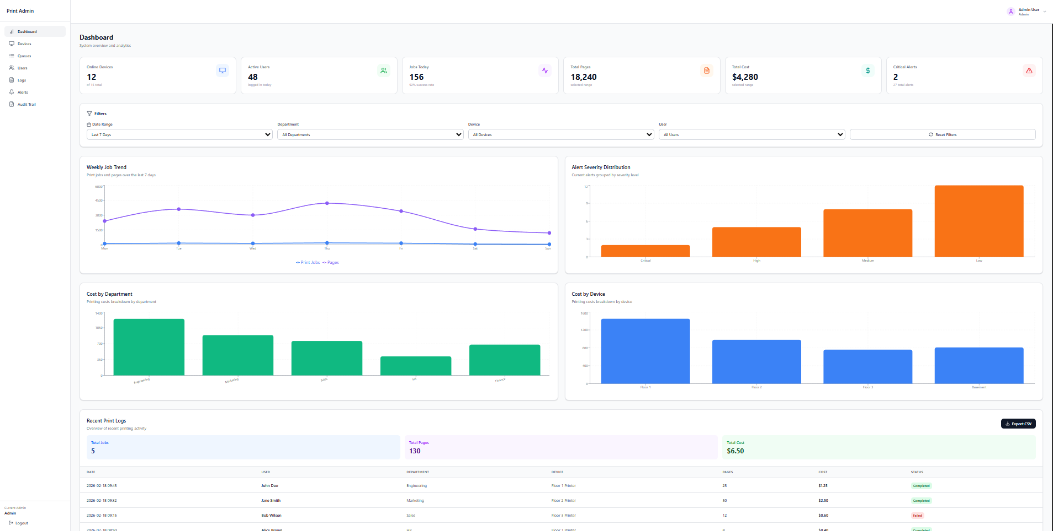
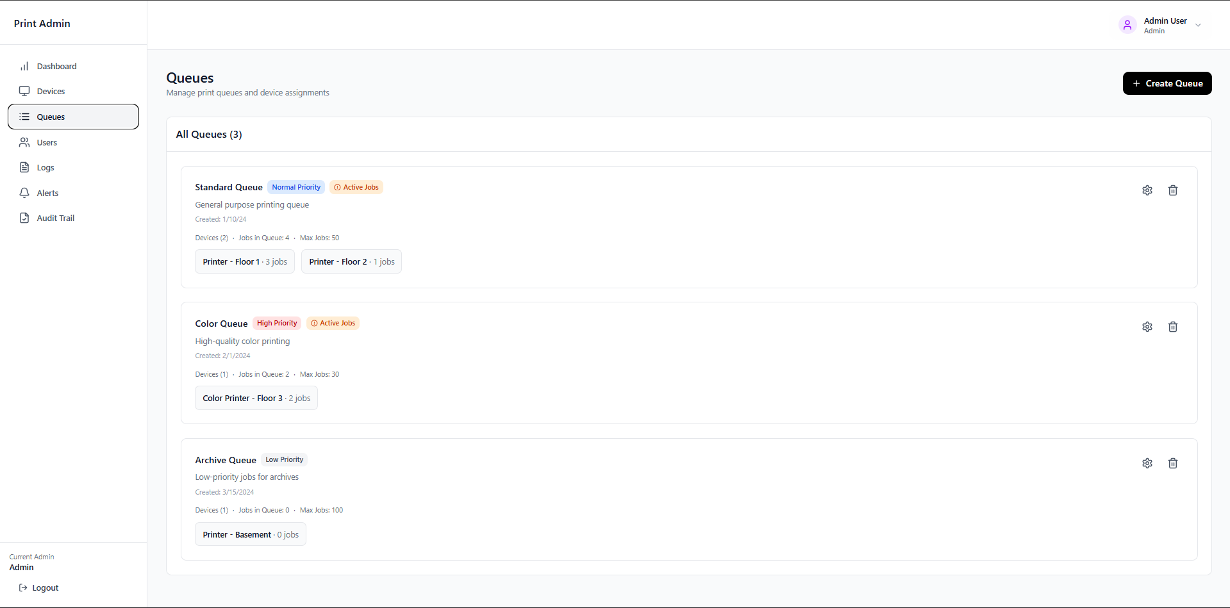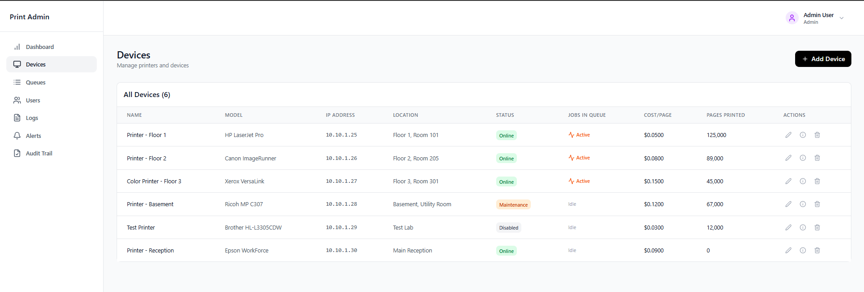
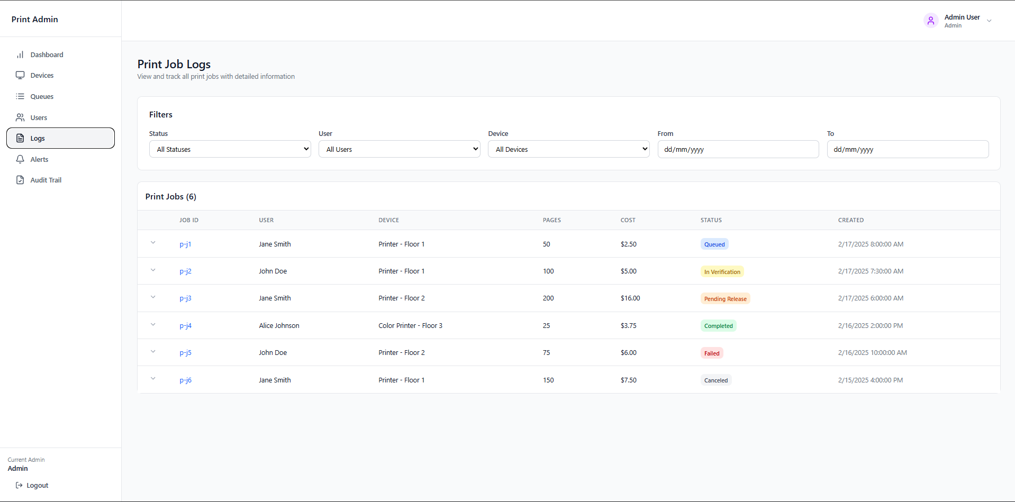
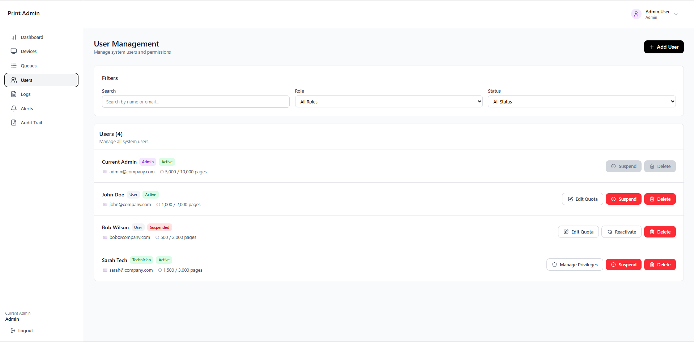
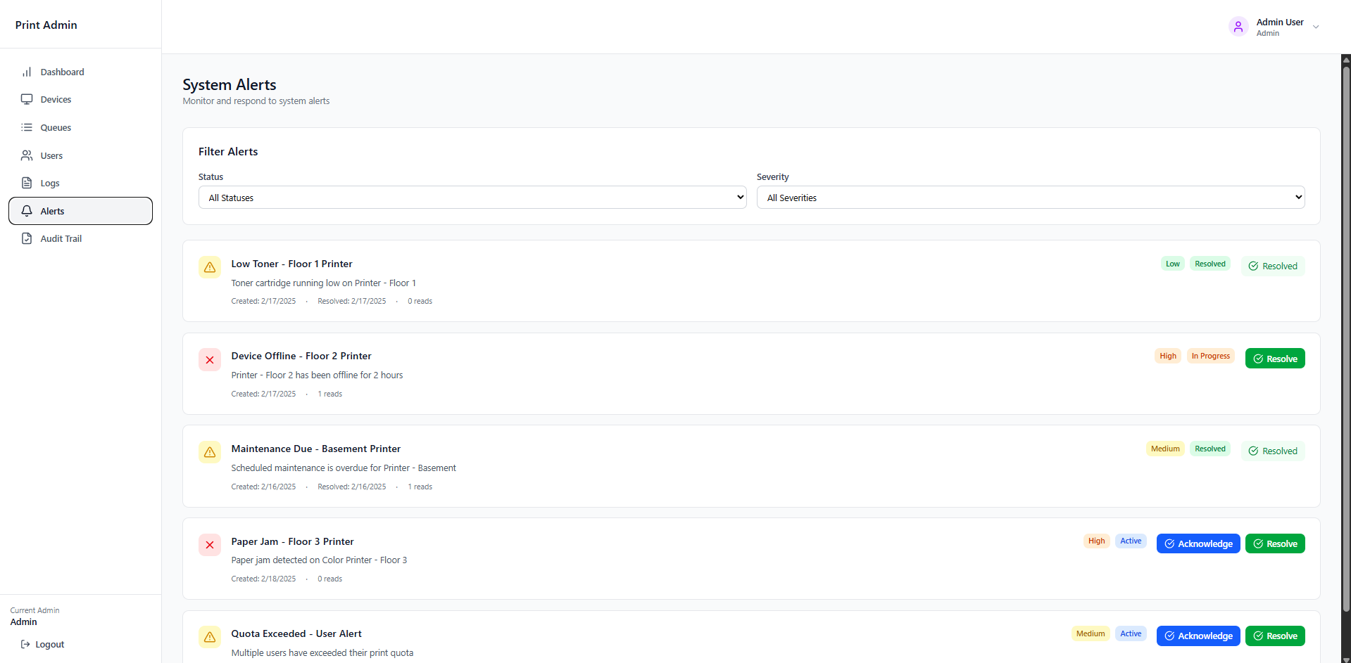
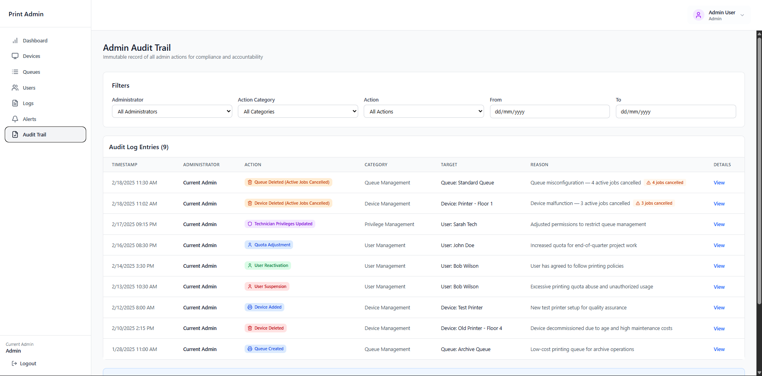

Technician Dashboard [https://www.figma.com/make/zXV5usocwXjqTyjLRz0ent/Technician-PMS?t=AhgwHPxhzLe2m3Az-1]
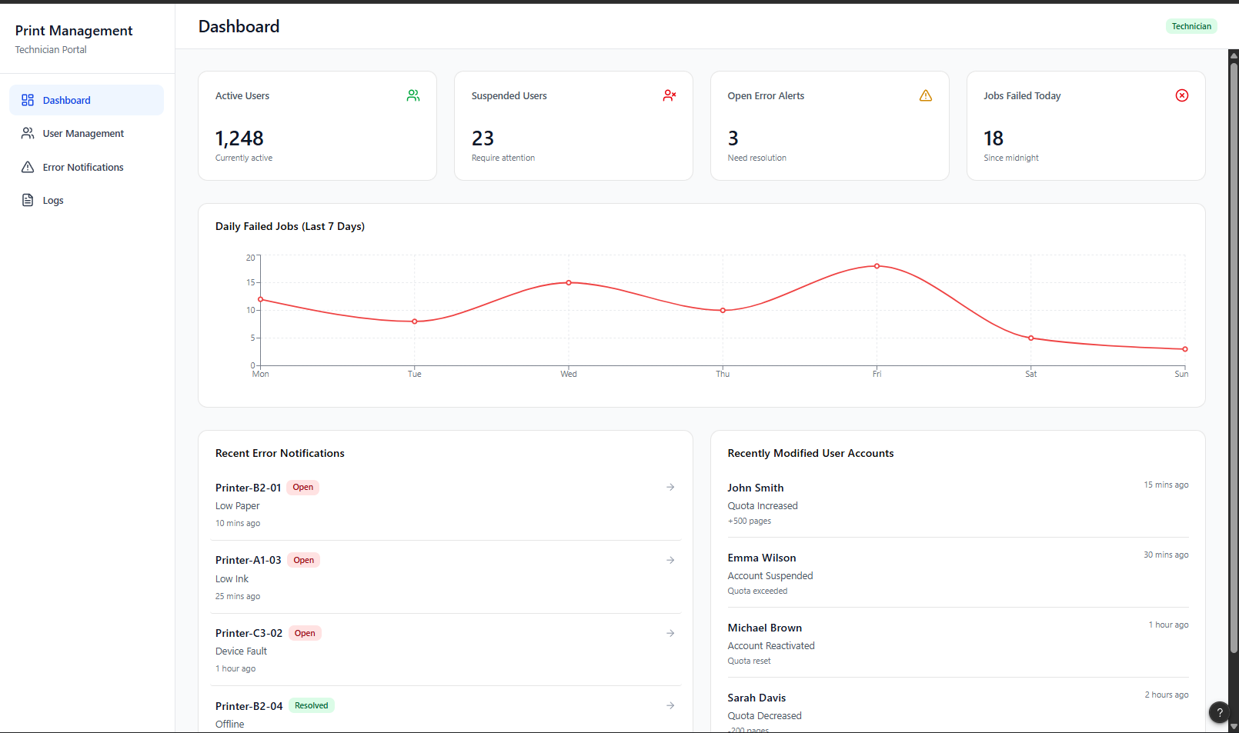
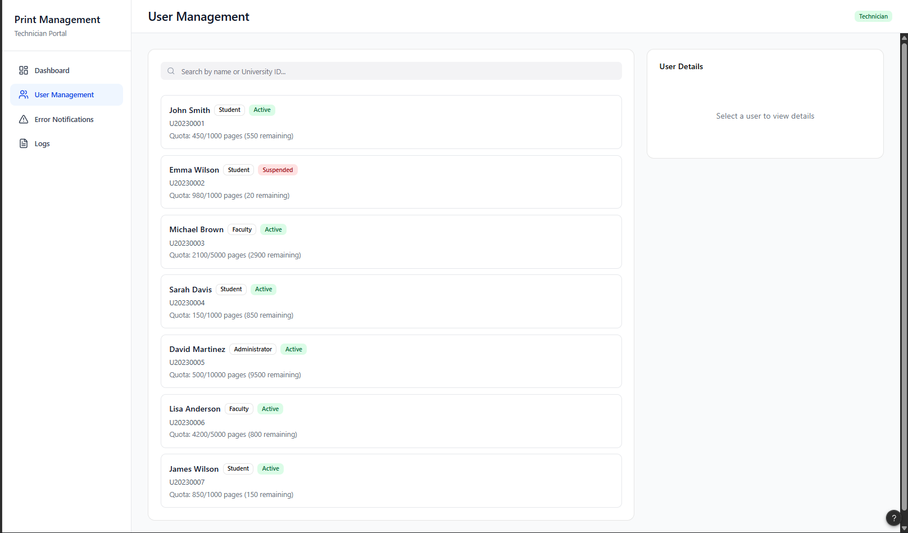

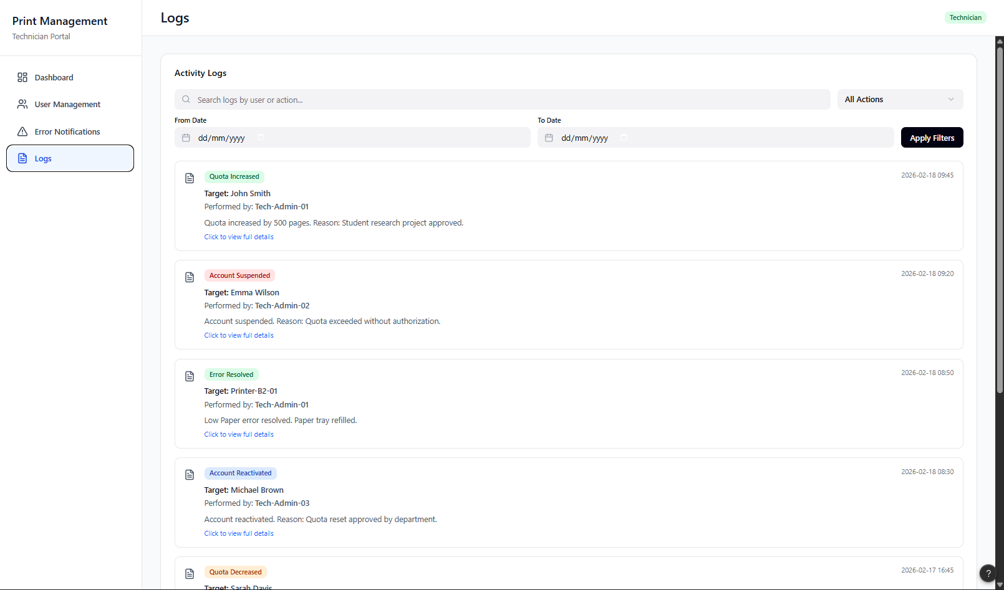

Users Dashboard [https://www.figma.com/make/dOfrNMeNw1vybturf2cuG4/User-PMS?t=AhgwHPxhzLe2m3Az-1]
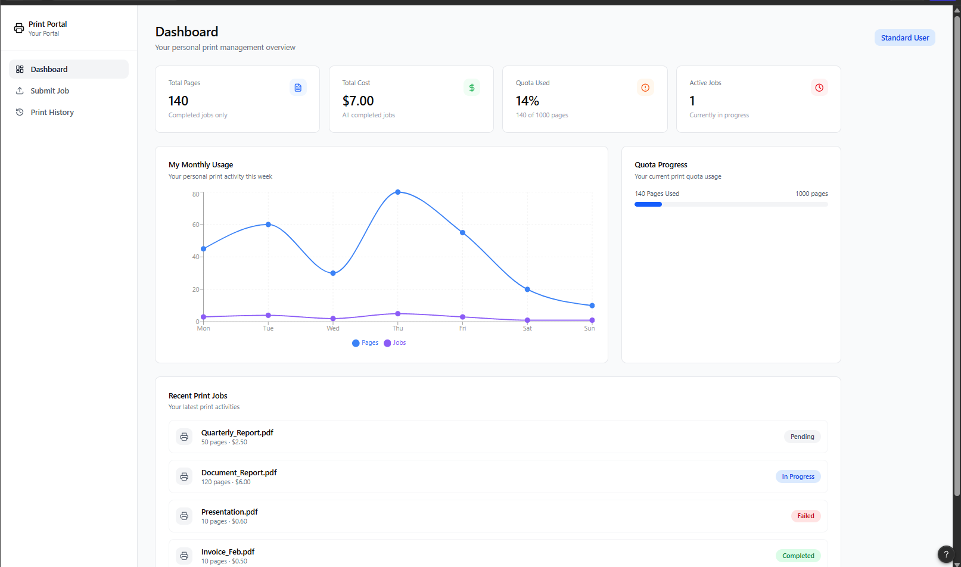
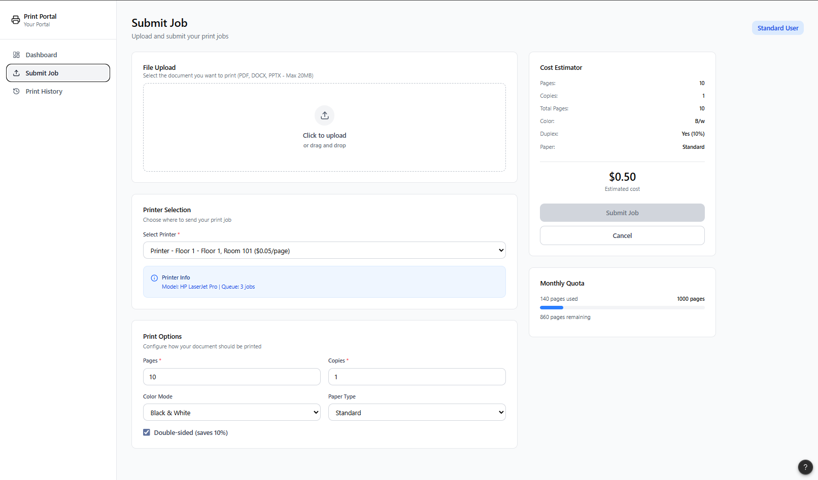


Figma Project Link [https://w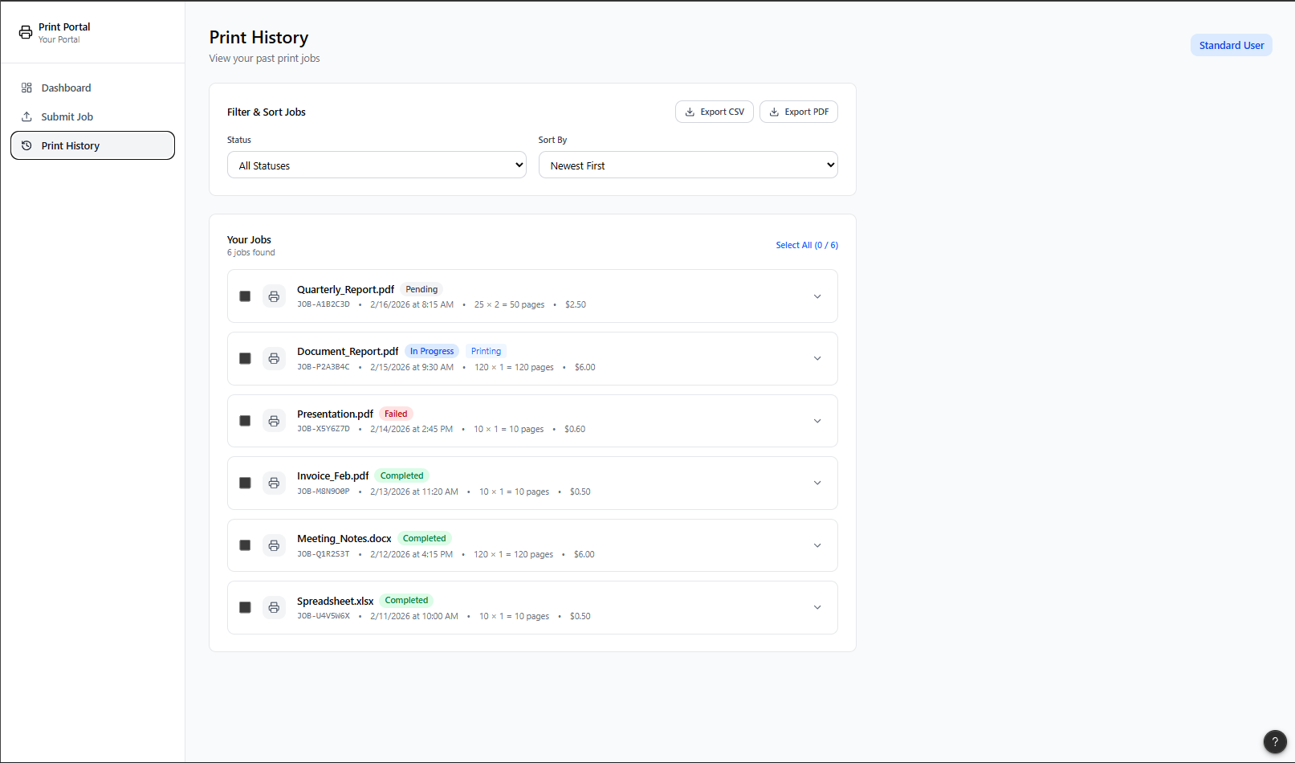ww.figma.com/files/team/1369054191536550891/project/230760201?fuid=136905418917656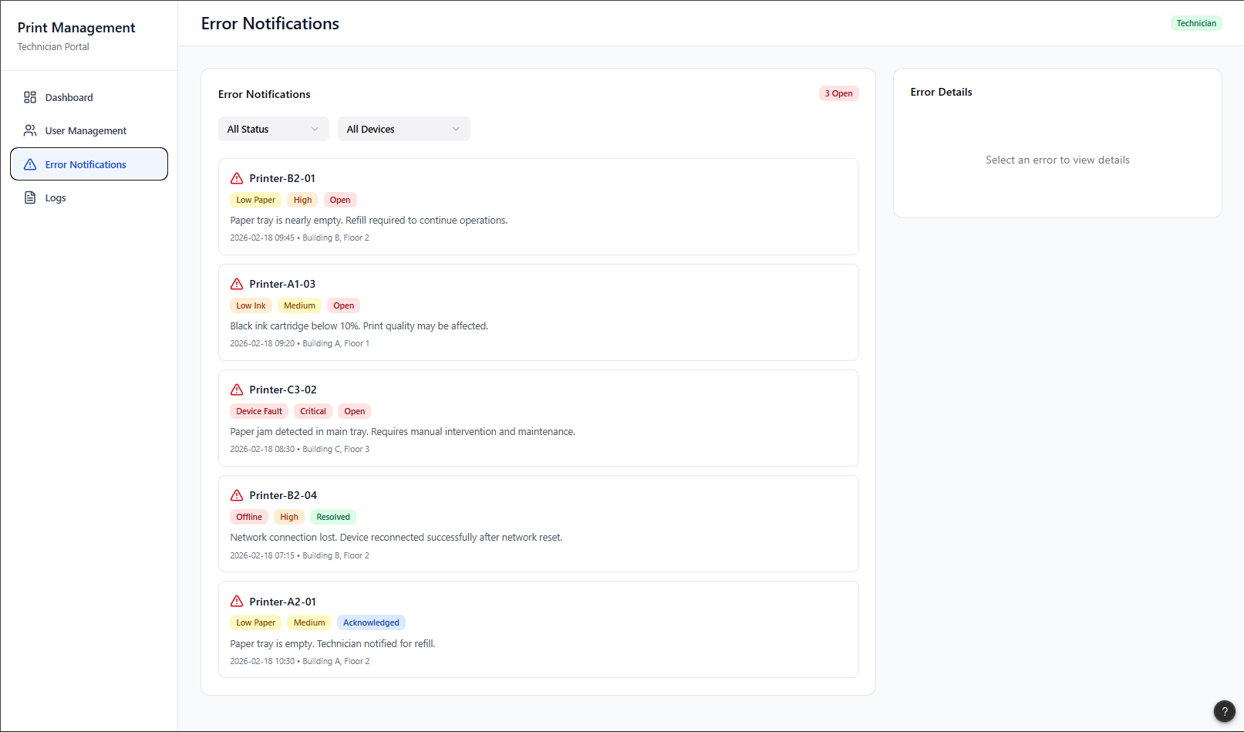3017]

